Weekly Construction Progress Report – Week 29
Harrow Bay Offshore Wind · 13 Jul – 19 Jul 2026
Elena Márquez · 20 July 2026 · HB-PM-RPT-2026-W29

1. Summary
No piling this week (seasonal piling restriction). The total remains 10 of 40 monopiles. The foundation campaign is 2 piles behind the Rev 2 baseline (12 planned). No weather downtime – MV Sea Atlas in port.
Area | Status | Comment
Overall schedule | Amber | 10/40 monopiles vs. 12 planned
Foundations | Amber | TPs installed: 10
Offshore substation | Green | Jacket installed 27 Jun
Cables | Green | Manufacturing on schedule
HSE | Green | No incidents

2. Progress
Metric | This week | Cumulative | Plan (cum.) | Variance
Monopiles installed | 0 | 10 | 12 | -2
Transition pieces installed | 0 | 10 | – | –
Waiting on weather (h) | 0 | 213 | – | –
Persons on board (avg.) | 103 | – | – | –
Man-hours MV Sea Atlas | 8,946 | 119,342 | – | –
Lost time injuries | 0 | 0 | 0 | 0
Recordable injuries | 0 | 1 | – | –
Near misses reported | 0 | 3 | – | –
HSE observation cards | 24 | – | – | –

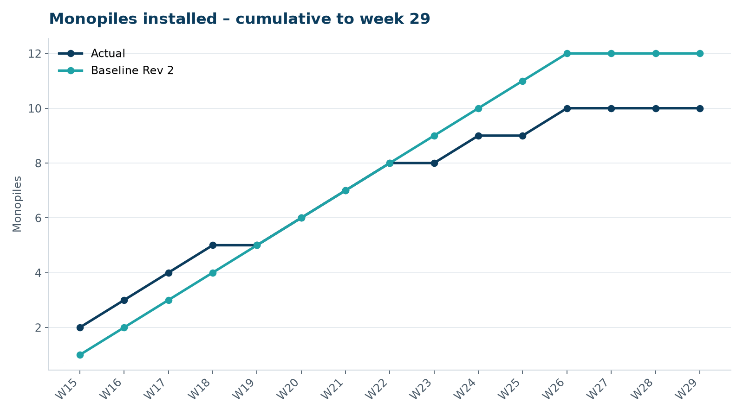
Figure 1 – Monopile installation progress, W15 to W29

3. Key activities this week
- Boulder clearance planning for export cable corridor: 214 boulders above 0.5 m identified between KP 4 and KP 22.
- Marlow Ecology continued passive acoustic monitoring during the no-piling period to establish a reference.
- Bolt tensioning campaign completed on all ten installed transition pieces.

4. Health and safety
No lost time injuries. 24 observation cards submitted; top theme: line-of-fire during lifts.

5. Environment
- No piling this week; passive acoustic monitoring stations HB-PAM-01 to -04 operational.

6. Issues and risks
- HB-RISK-001 weather: 0 h downtime this week.

7. Look-ahead next week
Remobilisation planning for August; load-out sequence.
Prepared by Project Controls (Gareth Lewis); approved by Elena Márquez. Distribution: project team, Steering Committee, Halden Turbine Systems, Lenders' Technical Adviser.

